**Preparation of Papers for '** **International Conference on Social Science and Humanity ‘(14pt Bold-Title Case)** …. (Type the title of your paper here)

**First A. Author1, Second B. Author2, Third C. Author (10 pt)**

1Sunan Ampel State Islamic University Surabaya, Surabaya, Indonesia (9pt)  
2Business or Academic Affiliation, City, Country (9 pt)  
3Business or Academic Affiliation, City, Country (9 pt)

(spasi)

|  |  |  |
| --- | --- | --- |
| [Creative Commons License](https://creativecommons.org/licenses/by-sa/4.0/) | | **DOI :** - |
| **Sections Info** |  | **ABSTRACT** (9 pt, italic, 1 spacing) |
| ***Article history:***  Submitted: November 23, 2022  Final Revised: January 11, 2023  Accepted: January 16, 2023  Published: January 31, 2023 | ***Objective:****The abstract is important because many journal readers first read the abstract to determine if the entire article is worth reading. An abstract is a shortened version of the paper and should contain all information necessary for the reader to determine: (1) what the objectives of the study were; (2) how the study was done; (3) what results were obtained; (4) and Novelty.****Method:****The abstract is important because many journal readers first read the abstract to determine if the entire article is worth reading.****Results:***  *The abstract is important because many journal readers first read the abstract to determine if the entire article is worth reading. An abstract is a shortened version of the paper and should contain all information necessary for the reader to determine: (1) what the objectives of the study were; (2) how the study was done; (3) what results were obtained; (4) and Novelty.* ***Novelty:*** *The abstract is important because many journal readers first read the abstract to determine if the entire article is worth reading. An abstract is a shortened version of the paper and should contain all information necessary for the reader to determine: (1) what the objectives of the study were; (2) how the study was done; (3) what results were obtained; (4) and Novelty. An abstract can be 150 – 250 words.* |
| ***Keywords:***  First keyword  Second keyword  Third keyword  Fourth keyword  Fifth keyword |
|  |  |

**INTRODUCTION (12pt)**

Introduction, introduction, introduction, introduction, introduction, introduction, introduction, introduction, introduction, introduction, introduction, introduction, introduction, introduction, introduction, introduction, introduction, introduction, introduction

The introduction needs to relate to the problems or issues being recognised and eventually leading the research questions. The structuring of the introduction part may vary. This section discusses the results and conclusions of previously published studies, to help explain why the current study is of scientific interest.

General to Specific Statement (Don't Zigzag statement). Approximately 2 pages (relative) which show the importance of the research issue raised and how it differs fromother papers. Requires Recent Journal References (last 5 years), avoid “in” quotes....in...and in the last paragraph it MUST be stated OBJECTIVES. Research Aim and Research Questions (Optional). Etc. …….

This article use size A4 paper and the margin layout is Top: 2cm, Bottom: 2cm, Right: 2cm, Left: 2,5cm. Use spacing 1,15cm and each new paragraph is entered with a distance 1cm. And use the Book Antiqua font type, 12pt.

**RESEARCH METHOD**

General background of research, general background of research, general background of research, general background of research, general background of research, general background of research, general background of research, general background of research, general background of research, general background of research, general background of research.

General description of research is important in order to show the basis of the research. It is like a very brief introduction to the methodology section as a whole.

Research Method consist of participants, instrument and procedures, data analysis*.* Research method consist of participants, instrument and procedures, data analysis.

Sample of research, sample of research, sample of research, sample of research, sample of research, sample of research, sample of research, sample of research, sample of research, sample of research, sample of research, sample of research, sample of research.

Instrument and procedures, instrument and procedures, instrument and procedures, instrument and procedures, instrument and procedures, instrument and procedures, instrument and procedures, instrument and procedures.

Data analysis, data analysis, data analysis, data analysis, data analysis, data analysis, data analysis, data analysis, data analysis, data analysis, data analysis. Etc. Data analysis, data analysis, data analysis, data analysis, data analysis, data analysis, data analysis, data analysis, data analysis, data analysis, data analysis. Etc.

This section provides all the methodological details necessary for another scientist to duplicate your work. For the qualitative research this part can be different. „Research Methodology“ chapter should convince a reader that this manuscript presents a solid and sound analysis.

**RESULTS AND DISCUSSION**

***Results***

Research results, research results, research results, research results, research results, research results, research results.

**Table 1.** Tables and figures should be valuable, relevant, and visually attractive. (Sub-titles (Subchapters) 12pt, Centered)

|  |  |  |  |  |  |  |
| --- | --- | --- | --- | --- | --- | --- |
| **Statements and subscales** | **Cronbach-α** | **KMO** | | L | **r/itt** | **Dissemination %** |
| XX | x | | x | x | x | % |
| XX | x | | x | x | x | % |
| XX | x | | x | x | x | % |

After the table and figure, press Enter once to continue the sentence in a paragraph.

Figures should be *carefully* explained in the text and cited in numerical order.

**Figure 1.** Comparison of success rate of items in the experimental and control class.

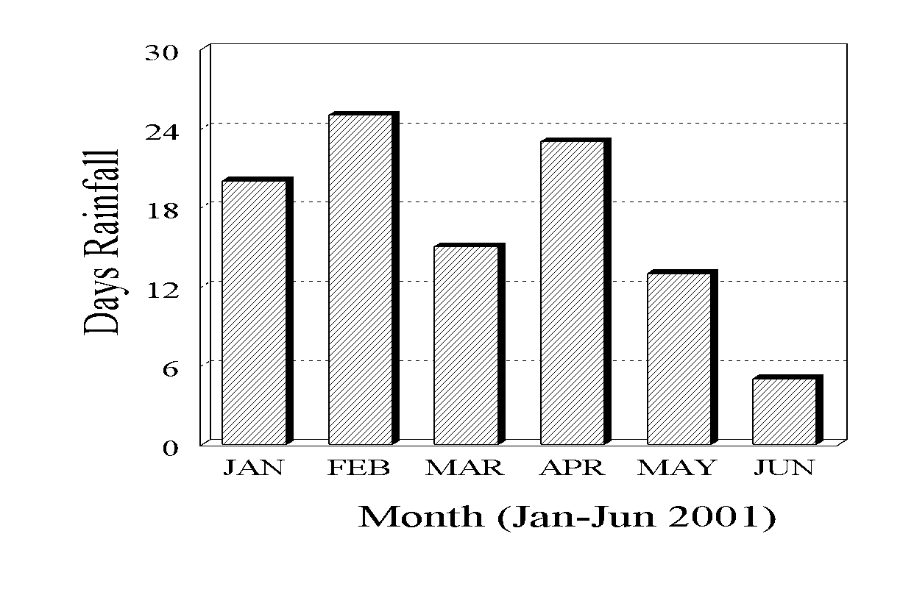

**Figure 2.** Clear line drawings are essential.

Research results, research results, research results, research results, research results, research results, research results. Results should be presented in details and discussed accordingly without any mix with other studies.

***Discussion***

Discussion, discussion, discussion, discussion, discussion, discussion, discussion, discussion, discussion, discussion, discussion, discussion, discussion, discussion, discussion, discussion, discussion, discussion, discussion.

The objective here is to provide an interpretation of your results and support for all of your conclusions, using evidence from your experiment (research) and generally accepted knowledge, if appropriate. Suggest future directions for research, new methods, explanations for deviations from previously published results, etc.

The objective here is to provide an interpretation of your results and support for all of your conclusions, using evidence from your experiment (research) and generally accepted knowledge, if appropriate. Suggest future directions for research, new methods, explanations for deviations from previously published results, etc.

The objective here is to provide an interpretation of your results and support for all of your conclusions, using evidence from your experiment (research) and generally accepted knowledge, if appropriate. Suggest future directions for research, new methods, explanations for deviations from previously published results, etc.

**CONCLUSION**

**Fundamental Finding :** Your conclusion should be the best part of your paper. A conclusion should: **(**1**)** stress the importance of the thesis statement, (2) give the essay a sense of completeness, and (3) leave a final impression on the reader. **Implication :** Your conclusion should be the best part of your paper. A conclusion should: **(**1**)** stress the importance of the thesis statement, (2) give the essay a sense of completeness, and (3) leave a final impression on the reader. **Limitation :** Your conclusion should be the best part of your paper. **Future Research :** Your conclusion should be the best part of your paper. A conclusion should: **(**1**)** stress the importance of the thesis statement, (2) give the essay a sense of completeness, and (3) leave a final impression on the reader.

**ACKNOWLEDGEMENTS (OPTIONAL)**

Acknowledgements of people, grants, funds, etc should be placed in a separate section not numbered at the very end of the paper.

**REFERENCES (IEEE, Minimum 16 references, 11pt)**

1. Byman, R., "Curiosity and sensation seeking: A conceptual and empirical examination," Personality and Individual Differences, vol. 38, no. 6, pp. 1365-1379, 2005. doi: 10.1016/j.paid.2004.09.004.
2. L. J. Cronbach and P. E. Meehl, "Construct validity in psychological tests," Psychological Bulletin, vol. 52, no. 4, pp. 281-302, 1955. doi: 10.1037/h0040957.
3. N. Geddis, "Transforming subject-matter knowledge: The role of pedagogical content knowledge in learning to reflect on teaching," International Journal of Science Education, vol. 15, no. 6, pp. 673-683, 1993. doi: 10.1080/0950069930150605.
4. Herráez, "Biomolecules in the computer: Jmol to the rescue," Biochemistry & Molecular Biology Education, vol. 34, no. 4, pp. 255-261, 2006. doi: 10.1002/bmb.2006.494034042644.
5. J. A. Johnson, "Units of analysis for the description and explanation of personality," in Handbook of personality psychology, R. Hogan, J. Johnson, and S. Briggs, Eds. Academic Press, 1997, pp. 73-93.
6. J. A. Johnson, "Units of analysis for the description and explanation of personality," in Handbook of personality psychology, R. Hogan, J. Johnson, and S. Briggs, Eds. Academic Press, 1997, pp. 73-93.

**(There should be a reference article published in a reputed international). It needs 70% of references from articles (last 10 years) and 30% of references from books).**

**Do not use Wikipedia for references. Do not use “et. al.” Provide issue numbers for papers. Reference section should not be used for commentary and notes.**

**Quick Reference Guide:** [**https://apastyle.apa.org/instructional-aids/reference-guide.pdf**](https://apastyle.apa.org/instructional-aids/reference-guide.pdf)

|  |
| --- |
| \***First A. Author (Corresponding Author) 10pt**  Department of Technology Education Faculty of Science and Technology,  Sunan Ampel State Islamic University Surabaya,  Jl. Ahmad Yani 117, Surabaya, East Java, 60237, Indonesia  Email: [corresp-author@mail.ac.id](mailto:corresp-author@mail.ac.id)  **Second B. Author**  Department of Technology Education Faculty of Science and Technology,  Sunan Ampel State Islamic University Surabaya,  Jl. Ahmad Yani 117, Surabaya, East Java, 60237, Indonesia  Email: [corresp-author@mail.ac.id](mailto:corresp-author@mail.ac.id)  **Second C. Author**  Department of Technology Education Faculty of Science and Technology,  Sunan Ampel State Islamic University Surabaya,  Jl. Ahmad Yani 117, Surabaya, East Java, 60237, Indonesia  Email: [corresp-author@mail.ac.id](mailto:corresp-author@mail.ac.id) |

**Note:**

1. Reference must contain at least 35 scientific journal articles (Last 10 Years ) for primer data.
2. Reference must contain at least 75 scientific journal articles (Last 10 Years ) for secondary data.
3. Originality is very important aspect of a research paper. Take great care to avoid plagiarism in your writing and be sure that any text you pull from outside sources is properly quoted and noted in your list of references.
4. A qualitative scientific paper is a description of an event, activity, observation, research or experience. The structure of a qualitative paper includes an abstract, introduction, background to the problem, the researcher's role, theoretical perspective, methodology, ethical considerations, results, data analysis, limitations, discussion, conclusions and implications, references and appendix.